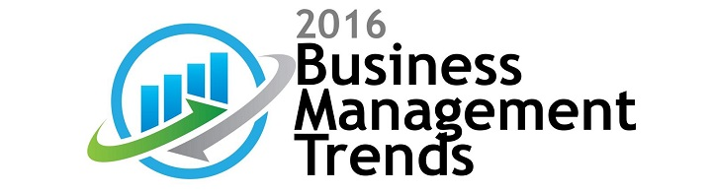
The purpose of our Business Management and Operations Trends 2016 survey is to identify the upcoming hot business management trends and themes in 2016, as well as some striking initiatives of the global operating companies across several industries. WGA conducted the Business Management and Operations Trends survey between October 1 and November 15, 2015, in which we had a total of 1195 responders to our Business Management and Operations Trends survey. Participants of the Business Management and Operations Trends survey were executive officers and vice presidents of publicly traded companies, operating in the United States.
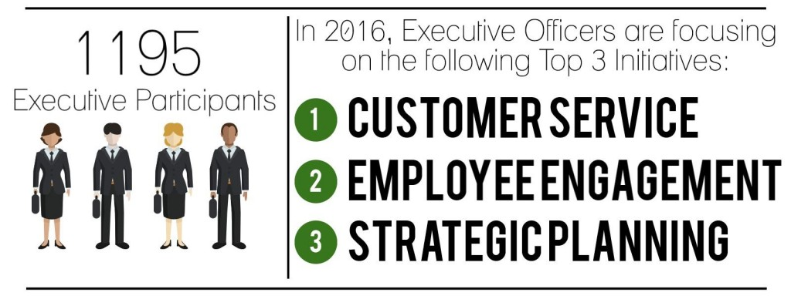
WGA Consulting is a global management consulting firm, helping clients make and execute the big decisions on strategy, operations and transformation. The firm focuses on solving areas of senior management concern, creating enduring value and delivering impactful results. We serve our clients in the areas of strategy consulting, management consulting and business transformation.
